Colouring pencils are versatile and popular tools used for a wide range of creative projects by artists, designers, students, and hobbyists alike. They consist of a core of pigment mixed with a binder, encased in wood, which allows the artist to draw, shade, and colour with precision and control.

Colouring pencils come in various types, grades, and styles, making them ideal for everything from casual doodling to detailed professional artwork.

**Tools you need when working with colouring pencils**

* Colouring pencil set
* Appropriate paper
* Pencil and eraser
* Sharpener or preferably a hobby blade
* Ruler

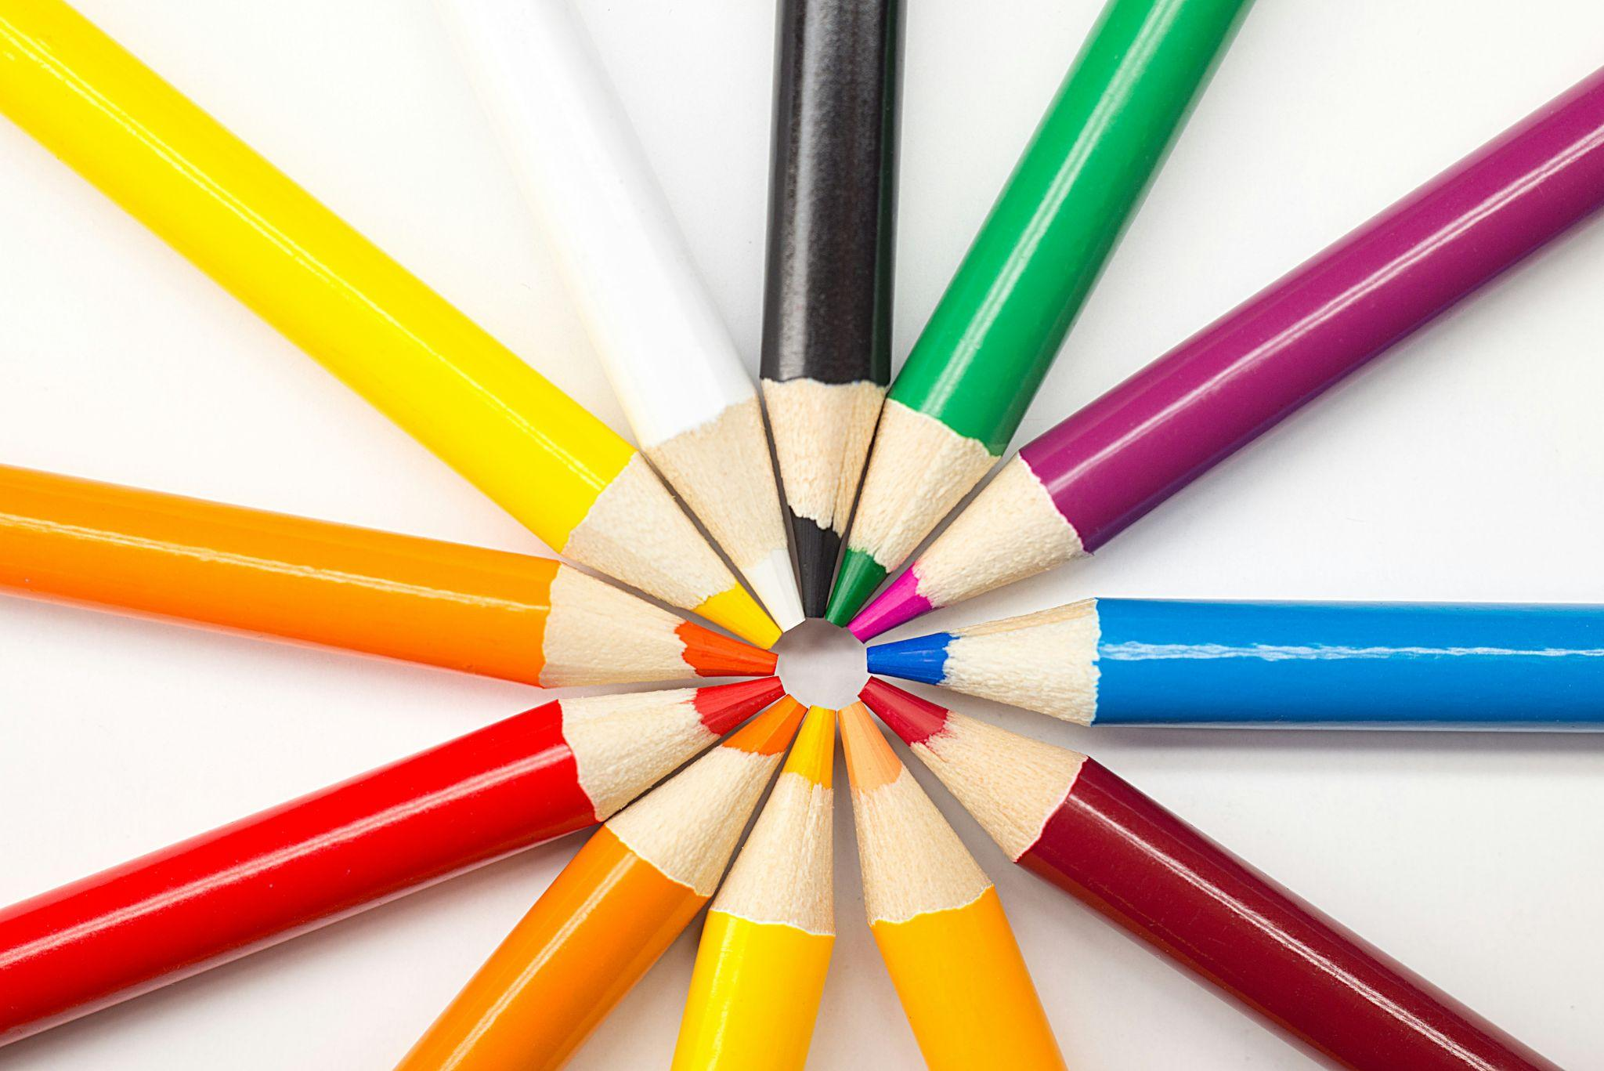

Fig. 1. Unsplash (n.d.), Colour pencils

**Tips**

* Even though you can buy a large variety of different colouring pencils, it is advisable to get a good quality set. The better quality colouring pencils contain a higher percentage of pigment, which will result in a deeper colour
* Prepare your colouring pencils by paring them to a point.
* Colouring pencils can be applied to any paper, however using paper with a slight texture instead of an overly smooth paper is a better option.
* Don't apply too much weight to the colouring pencil when you start rendering. A single pencil can produce variants of colour strength simply by changing how much weight you apply.
* Experiment with shading and texture. Colouring pencils can appear somewhat flat if you don't apply some technique to your drawing.
* Factor the direction and intensity of light hitting the surface of an object and apply the weight of the colouring pencil accordingly.
* The white colouring pencil is used to lighten a colour in addition to blending two or more colours together. The black colouring pencil is used to darken a colour in addition to adding shadow to a drawing.

## Preparing to work with a new colouring pencil set

Before you begin working with new pencils on a project, it is a good idea to create a “colour card”. This will help you to become familiar with how your pencils will behave, and to trial the exact results you can get from each colour in your box set.

In order to do this, get a piece of paper, and with each pencil from your set, quickly draw a square and fill it with colour. Next to each square, write the name of the colour you have used (you can find this on each individual pencil). This way, you will be able to see the result of each colour, without the risk of using the wrong tone for your work. Experiment with different saturation of the colours.

#### **Important:**

When you get a new set of colouring pencils it's worthwhile completing this job, as it will give you a much better understanding of each colour. It means that instead of applying a colour directly onto a drawing, without knowing exactly what colour you will get, you can refer to your own personal colour card. This undertaking can be completed for every rendering material you are using.

It is worth taking a little time and effort to complete this job as you will reap the benefits as you progress with your colour rendering. Naturally, this can be applied to any colour rendering material but remember that you should apply the colour onto the appropriate paper.

For example applying watercolour paint to ordinary paper will not give you an accurate result.

## Different types of rendering techniques

## Blending

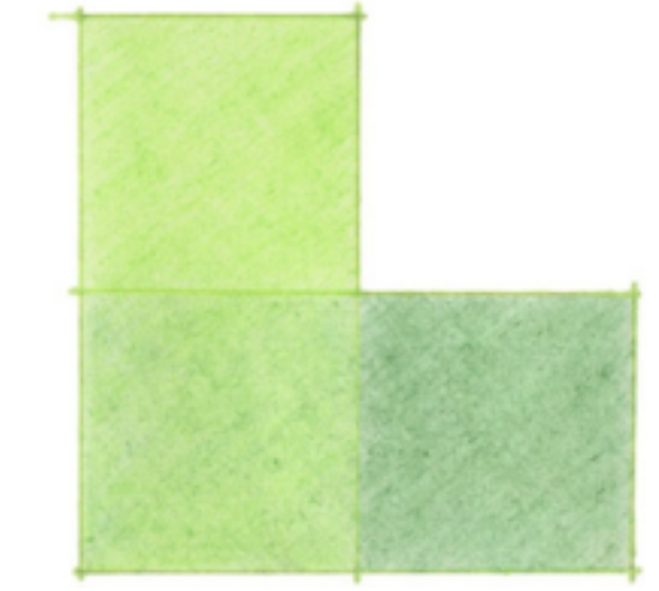

Fig. 2. Light Green and Dark Green

Blending is the combination of two colours put next to each other with a phase of transition in which these two colours overlap. Essentially, blending is the technique used to create a gradient. Two different types of gradients are monochromatic and polychromatic. A monochromatic gradient involves transitioning the same colour from light to dark, or dark to light. And polychromatic gradients include two or more colours with a gradual transition between each one of these.

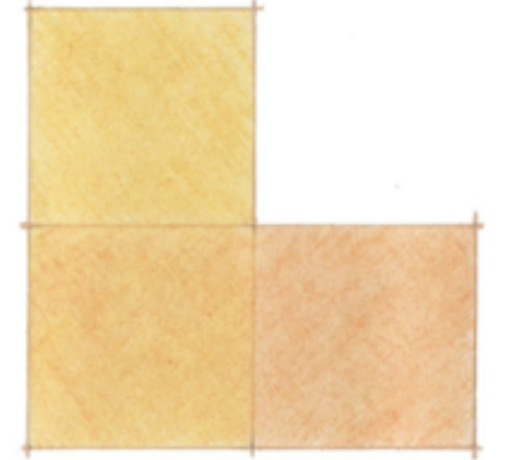

Fig. 3. Naples Yellow and Orange

## Hatching

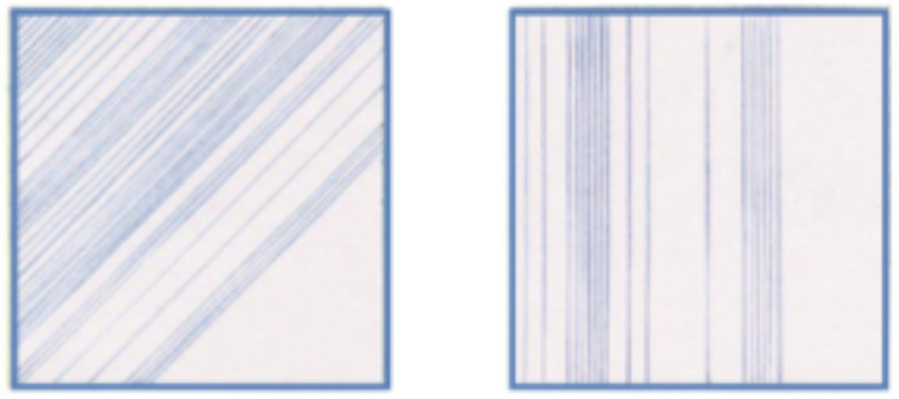

Fig. 4. Angular hatching (left) and vertical hatching (right)

Hatching simply involves drawing a series of parallel lines. Depending on the density of colour you want, the lines will be drawn either close together or farther apart. The closer each line is drawn together the stronger the colour will appear.

The lines can be drawn close together, far apart, or a combination of both. For this technique the pencil is lifted from the paper after each line and then placed down again for each new line you draw.

When hatching, make sure you work from top to bottom of your drawing, in order to avoid smudging.

## Cross-hatching

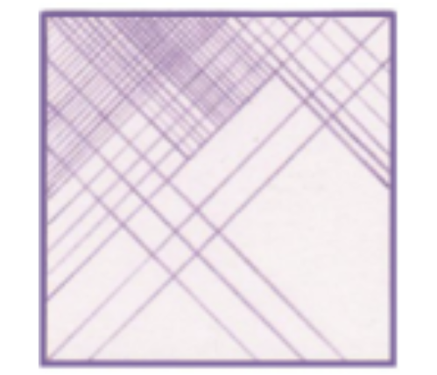

Fig. 5. Example of cross-hatching

Cross-hatching involves drawing a series of parallel lines and then drawing another series of parallel lines going in the opposite direction. The same rules apply as with hatching, however this rendering technique can be used to greater effect to create shading in a drawing. In order to create cross hatching, we build on the angled parallel lines. So, we will start with parallel lines at a 45° angle, then draw them at the opposite angle, then we can add vertical and horizontal lines. Should we wish to add more density, we can then build the colour up more with parallel lines at a different angle (60°, 80° etc). In addition you can craft an interesting texture using cross-hatching.

## Feathering

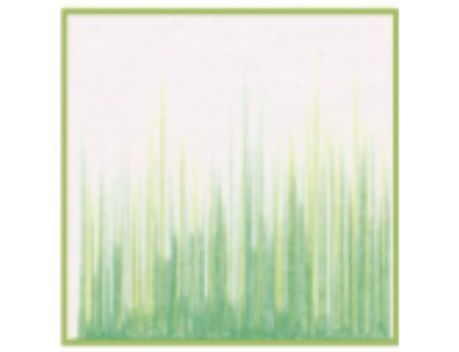

Fig. 6. Example of feathering

Feathering involves drawing a series of lines with a varying amount of colour density which will result in a gradient like effect.. The process involves putting the nib of the pencil onto the paper and then “flicking” it towards your chosen direction.

It is similar to both hatching and cross-hatching in that you lift the pencil from the paper after each line, however feathering will create a variation in colour along one line.

This technique is very effective for creating and replicating material finishes such as grass, or carpet.

## Stippling

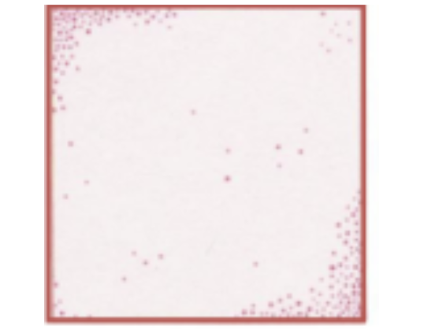

Fig. 7. Example of stippling

Stippling involves drawing a series of tiny dots. Depending on the density of colour you want will depend on how close you draw one dot next to another. The closer each dot is drawn together the stronger the colour will appear.

In order to achieve a good result the colouring pencil should be sharp. If the pencil is dull then the desired effort is often lost. This rendering technique can be used to add subtle texture to a drawing and is very effective in creating shadows on surfaces, regardless of their finish.

It can help indicate anything from a flooring to a wall finish. In addition the dots can signify a gradient or can be used for a shadow.

## Layering

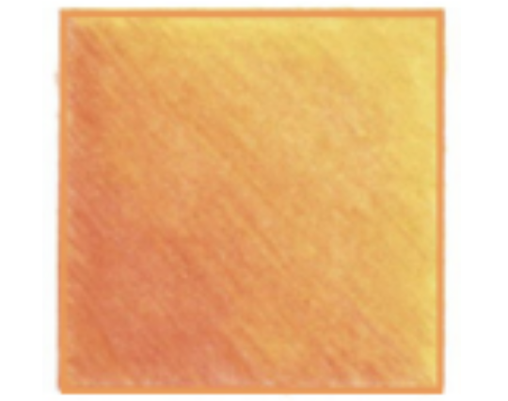

Fig. 8. Example of layering

Layering is actually a type of blending, however, this technique only involves one colour, and focuses on building up the density of that colour, from light to dark. It involves drawing one colour over another, starting from the lightest and progressing to the darkest colour. Firstly the lightest colour is applied to the paper and then a secondary colour and so on. Each colour should be overlaid onto the lighter colour and built up gradually.

Beware of adding too much colour onto the paper as it will start to wear and possibly tear the surface of the paper.

## Burnishing

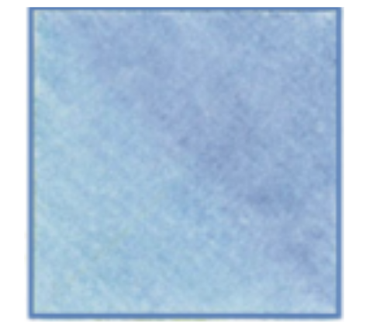

Fig. 9. Example of burnishing

Burnishing is the technique in which two colours will be blended in order to bring out the “shine” of the pencil. In order to burnish a surface, we use tools such as a piece of cotton wool, tissue paper, a brush or even our finger. Burnishing polishes the surface area and unifies the two colours in order to create a more even and shiny finish.

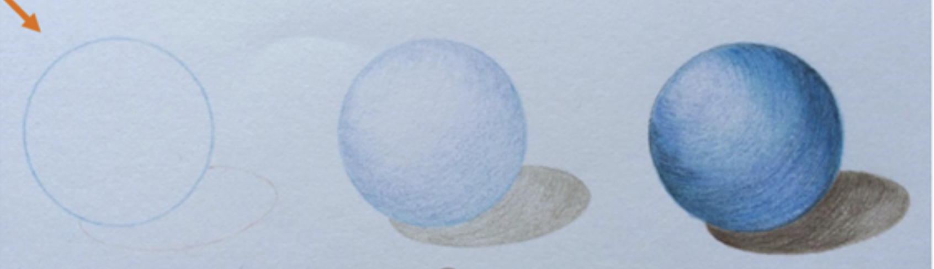

Fig. 10. Overview of how to create a sphere

## Advantages of Colouring Pencils

* **Control and precision:** Colouring pencils offer excellent control, allowing artists to create both detailed and bold strokes.
* **Portability:** They are easy to carry, making them convenient for drawing on the go.
* **Minimal setup:** Unlike paint, colouring pencils require no additional materials like brushes or water, making them clean and easy to use.
* **Low maintenance:** They don’t dry out or require special care, making them long-lasting and reliable.

Working with a new set of colouring pencils is all about experimentation and discovery. Take your time to test different techniques, explore blending, and adjust to the feel of the pencils. By practising, you'll develop your unique style and get the most out of your new rendering tools.